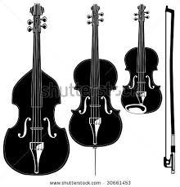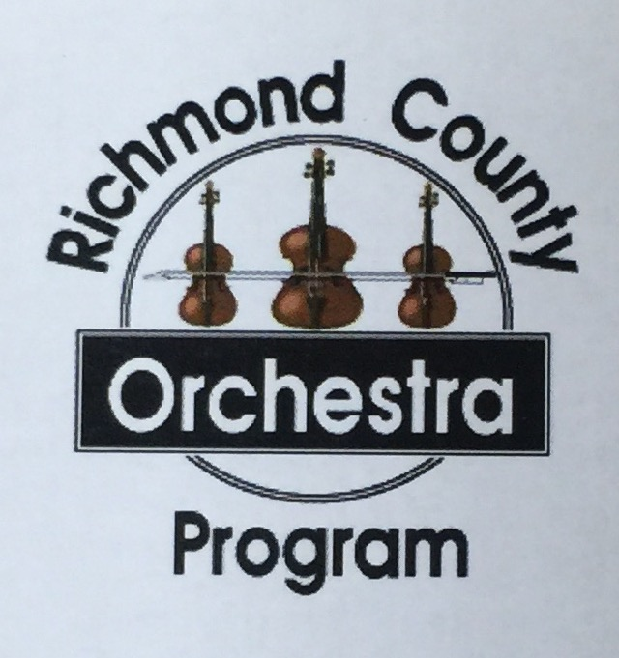

5th Period Cross Creek Orchestra Class Syllabus, 2025-2026 School Year

**Instructor:** Rochelle Garman

E-mail (best way to contact me): garmaro@boe.richmond.k12.ga.us

**Class Location:** Auditorium

**After school County-wide Rehearsals:** Tubman Educational Learning Center

**Course Description:** This course is primarily a performance group. Students will perform assigned pieces of music and participate with other students to demonstrate an evolving understanding and mastery of his/her chosen string instrument. Knowledge of Western classical music history, terminology, and theory will also be included. Your grade will be based on mastery of learning objectives through daily performance, playing quizzes and tests, attendance at required auditions, rehearsals, and concerts, and music history and theory quizzes and tests.

**Assignments:**  All students will have access to the 2025-2026 Combined Cross Creek Orchestra Canvas Course. Many of their assignments and copies of letters and music will be posted in Canvas. Please check the Orchestra Canvas course for updates.

**Grading:** Please see the attachment in the back.

**Richmond County Honor Orchestra*:***Theorchestra is an extension of the string class. You are HIGHLY encouraged to audition and attend rehearsals on Tuesday nights There is an audition and weekly evening rehearsals at **Tubman Education Center**, 1740 Walton Way. Amy Ellington/Christopher Connolly, Directors*ellinam@boe.richmond.k12.ga.us/connoch@boe.richmond.k12.ga.us*

**Auditions**: Tuesday, August 26, 2025 6:00-8:00p.m. at the Tubman Learning Center

**Rehearsals**: Tuesday evenings, 6:00-7:20, the director may extend certain rehearsals as

needed. First rehearsal TBD.

**Teacher Absence, Irregular Schedule:** Please note that I’m not on campus until shortly before the class period starts because I also teach at Butler High School, Pine Hill Middle, McBean,Goshen and Hains Elementary. Students are to report to Mr. Flemming in the Band Room whenever I’m out or the class period starts at an irregular time and I’m not in the Auditorium.

**Learning Objectives:**

* Singing, alone and with others.
* Performing on stringed instruments, alone and with others, to produce music.
* Reading and notating music.
* Creating music by improvising melodies and harmonies.
* Listening to, analyzing, describing, and evaluating a wide genre of music.
* Understanding the relationship between music and our history and culture, as well as the history and culture of others.
* Using music as a communication with others in our community.

**Required Materials That you are responsible for bringing to class every day:**

1. **Your instrument: a violin, viola, cello or bass (**or tell me you are requesting use of a county-owned instrument)
2. **a rag** to wipe the rosin off the instrument,
3. **tuning & metronome app (which is free)**
4. **a pencil**, (6) **Rosin**, (7) **Music given to you**. (8) All students will be responsible for the **maintenance of his/her instrument**, whether owned by the student or the county. **Spare, new strings (Violin E, A, Viola A) stored in the case are highly recommended.**

**CLASS RULES**

ARRIVAL

1. Take care of restroom needs before class. You are counted tardy when the tardy bell rings unless you are in the room. If another teacher needs you during our class time, give me a note at the beginning of class so I can give you any music or information you need prior to going back to that class.
2. Bring the required materials listed above to class everyday.
3. Be set up and completely ready by the time instruction starts. Do not socialize when you should be setting up.

DURING CLASS

1. Handle and store your instrument and materials responsibly at all times.
2. We do not eat during class, this includes gum.
3. Keep fingernails short.
4. Phones out at improper times will be given a chance to put the phone away. If

this continues on the same day or becomes habitual, phones will be taken up for the rest of the class.

1. All students are expected to keep the classroom orderly by placing all materials in designated areas.

AT THE END OF CLASS

1. Please listen to all closing remarks without packing up. Then remove all of your materials from your work area.
2. Cell phones-we will follow the county’s expectations.

A parent should e-mail the orchestra director if extenuating circumstances force the student to

miss a concert or have excess rehearsal absences, as discussed below.

For each **concert** performed, a grade of 100 is posted. If a concert event is missed, at the discretion of the director, this grade may be dropped from the average or make up work assigned.

Home practice is required for you to progress in the orchestra. If sufficient progress is not being

made, we will use practice charts and other methods to help get you back on track.

Please let me know if you have any questions or concerns.

Returning the information below the dotted line will be the first written grade of the year

**Rochelle Garman, Richmond County Orchestra garmaro@boe.richmond.k12.ga.us**

-------------------------------------------------------------------------------------------------------------------------------

I, ______________________________________ have read and understand the student

(student signature)

expectations for the High School Orchestra Class as of ______________.

I, _______________________________________ have read and understand my child’s

(parent or guardian signature)

expectations for the High School Orchestra Class as of ________________.

Home address: _____________________________________________________

Phone numbers: ____________________________________________________

E-mails ___________________________________________________________

Please put a star next to the best way to reach you.

I’m looking forward to having a great year!